25.029 |  | Trampoline square 1540 х 1540 (Braided ribbon)
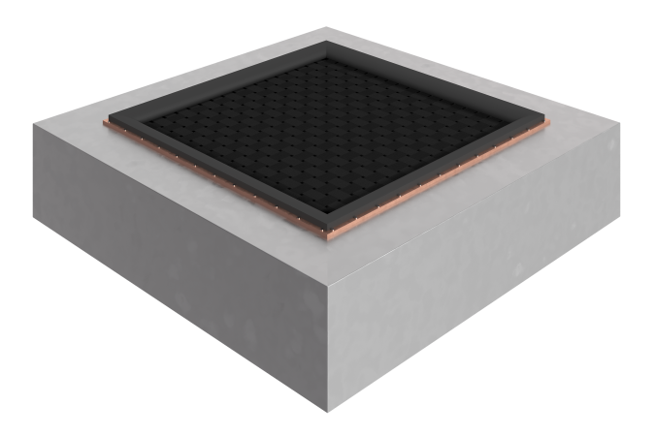

Size, mm: | 1540x1540x380 | Weight, kg: | 175
Material characteristics
Materials: metal, rubber.
Package includes: trampoline - 1 pc.
The built-in square trampoline is supplied as a single element, ready for installation, and includes a welded frame made of galvanized steel sheets 3-4 mm thick, a web of polyester belts, the belts can withstand 4.5 tons of breaking force.
Element coating:
- metal - hot zinc

