ML6517.1 |  | Park sofa
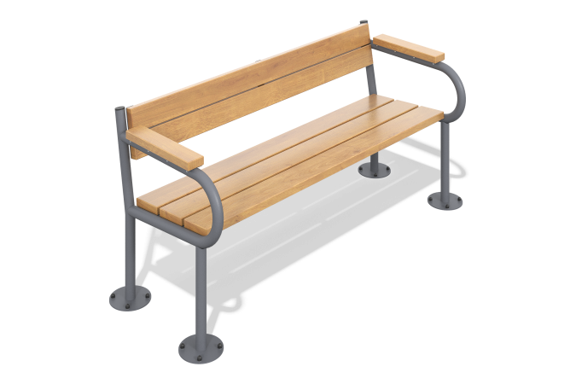

Size, mm: | 665x1640x770 | Weight, kg: | 47.3292
Material characteristics
Materials: metal, pine
Package: assembled sofa - 1 pc.
The park sofa is made of planed softwood board measuring 35 x 140 x 6000.
The equipment uses stainless steel fasteners. The protruding parts of the threaded connections and open parts of the pipes are covered with plastic plugs.
Coating of elements:
- metal - powder zinc primer, powder paint;
- timber - glazing primer, water-dispersion varnish.

