25.026 |  | Trampoline Rectangular with light 3000х1000 (rubber)
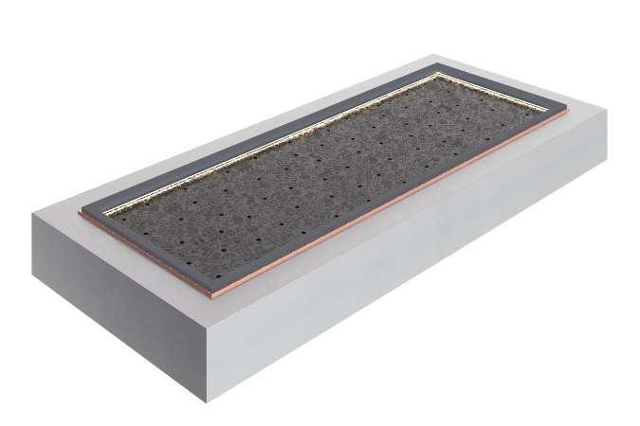

Size, mm: | 1560x3560x400 | Weight, kg: | 412
Material characteristics
Materials: metal, rubber.
Package: trampoline - 1 pc.
The built-in rectangular trampoline with lighting is supplied as a single element, ready for installation, and includes a welded frame made of galvanized steel sheets 3-4 mm thick, a reinforced rubber sheet with a tread 7-8 mm thick and galvanized springs 140 mm long with a load of up to 55 kg. The springs are attached through anti-friction bronze bushings, eliminating wear and creaking, which are subject to replacement every 3 years.
Coating of elements:
- metal - hot zinc"

