40.022 |  | Meteor
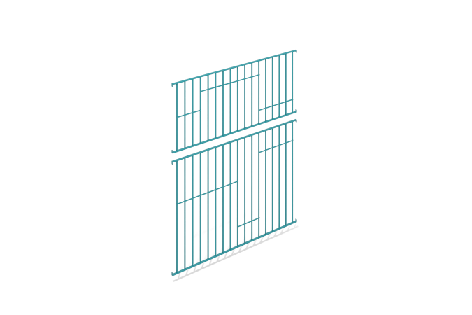

Size, mm: | 40x2920x3600 | Weight, kg: | 67.623
Material characteristics
The span consists of two structures independent of each other that serve to enclose the playing area.
Each structural element is made of profile metal rectangular pipes welded together with a cross-section of 40 mm x 20 mm and a wall thickness of 2 mm and
profile metal square section 20 mm x 20 mm and a wall thickness of 1.5 mm; connecting plates made of sheet steel 3 mm thick are welded to the ends of the rectangular profile.
Along the entire length of each span element, 3mm thick metal strips are welded at different levels.
The spans are painted with polymer paint.

