25.032 |  | Trampoline Rectangular 3000х1000 (Braided ribbon)
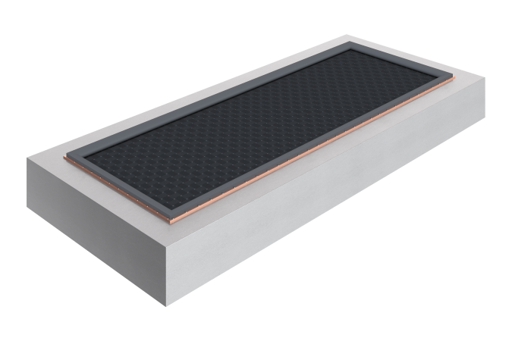

Size, mm: | 1560x3560x400 | Weight, kg: | 390
Material characteristics
Materials: metal, rubber.
Package includes: trampoline - 1 pc.
The built-in rectangular trampoline is supplied as a single element, ready for installation, and includes a welded frame made of galvanized steel sheets 3–4 mm thick, a web of polyester belts, the belts can withstand 4.5 tons of breaking force.
Element coating:
- metal – hot zinc

