30.093 |  | Target Squares
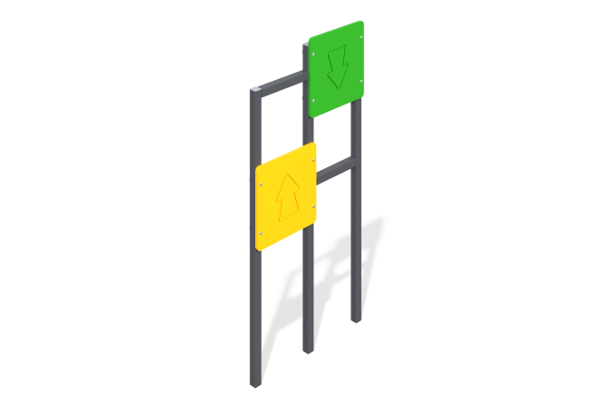

Size, mm: | 80x720x1500 | Weight, kg: | 19.189
Material characteristics
The “Squares” double target consists of a frame made of a metal pipe with a square section of 40 mm x 40 mm x 3 mm, on which shields made of 2/2 15 mm plywood are attached.
The shields have thematic designs made with a milling cutter. Metal is painted with basalt-gray polymer paint, plywood panels are painted with polymer paint, etc. All open parts of pipes and bolted connections are closed with plastic plugs of the appropriate size. Fastening is made using furniture bolts M6 mm x 65 mm and nuts M6 mm. Installation is carried out by fastening through bolts to the embedded part, which is deepened by 0.7 m, followed by concreting.
Equipment:
Support posts - 3 pcs.
Shield - target - 2 pcs.
Fasteners - 1 set.

