16.055 |  | Spring Rider Star
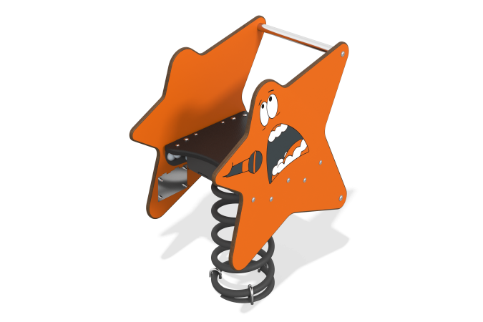

Size, mm: | 380x600x805 | Weight, kg: | 30.16
Material characteristics
Materials: metal, stainless steel, HPL plastic 14 mm thick, moisture-resistant laminated plywood 18 mm thick with anti-slip coating.
Rocking chair on a metal spring with two side panels made of HPL plastic 14 mm thick in the shape of a star, a seat made of moisture-resistant laminated plywood 18 mm thick, crossbars for legs and arms made of stainless steel. Decorative elements and designs are applied using UV printing.
Contents: base with spring – 1 set, rocking chair sides – 2 pcs., seat – 1 pc., crossbars – 2 pcs., fastening kit – 1 pc.

