17.033 |  | Rubber Seat
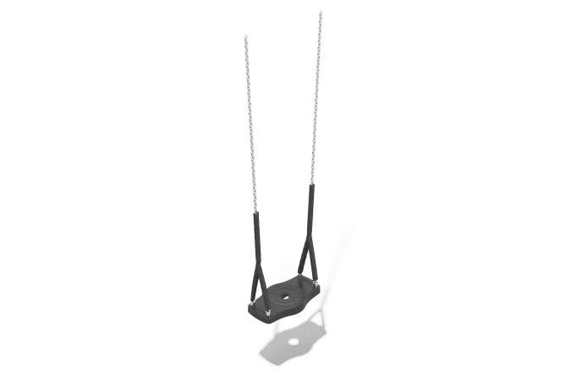

Size, mm: | 240x440x1482 | Weight, kg: | 5.855
Material characteristics
Materials: metal, rubber.
Complete set: rubber suspension – 1 pc., fastener kit – 1 pc.
The design consists of:
Anti-vandal seat for children's swings. Made of thermoplastic elastomer, reinforced with an aluminum plate.
Suspension made of galvanized round-link chain, 6 mm link. Fastened to the seat through galvanized bushings with M8 x 20 thread. Fixed at the bottom with a washer and a self-locking nut M8.
Protruding parts of threaded connections and open parts of pipes are covered with plastic plugs
Coating of elements: metal - powder zinc primer, powder paint.

